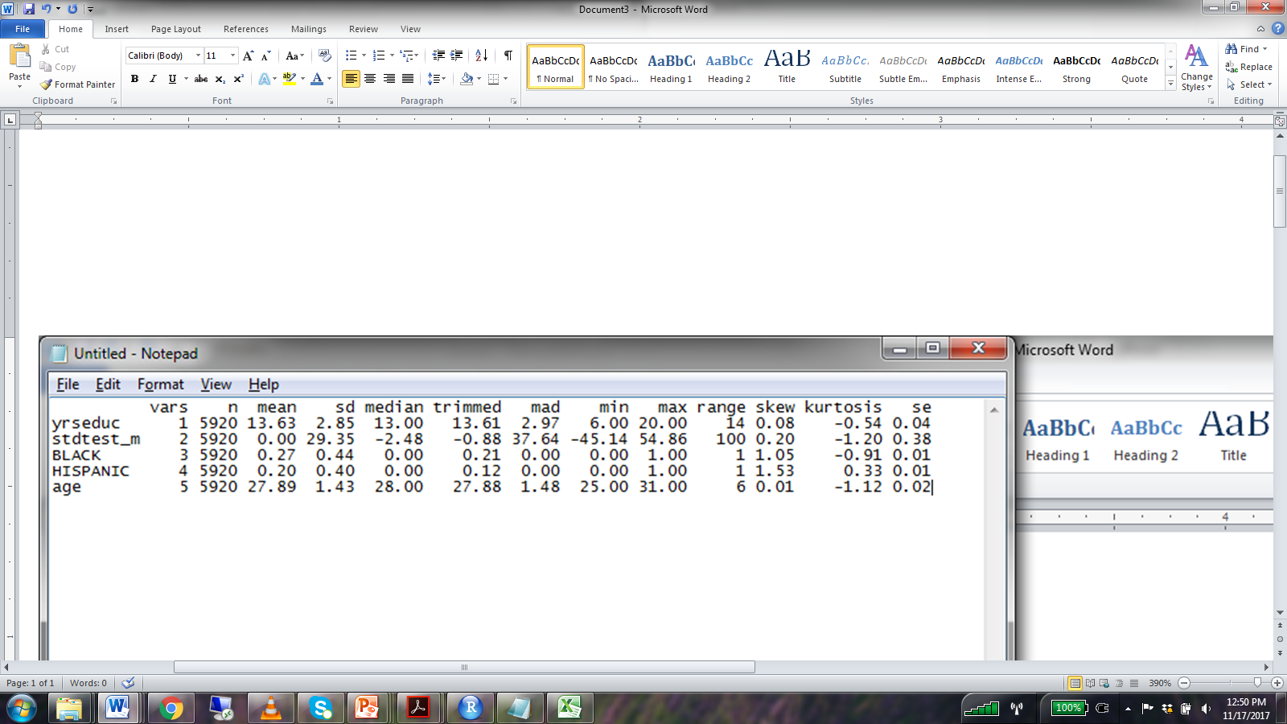

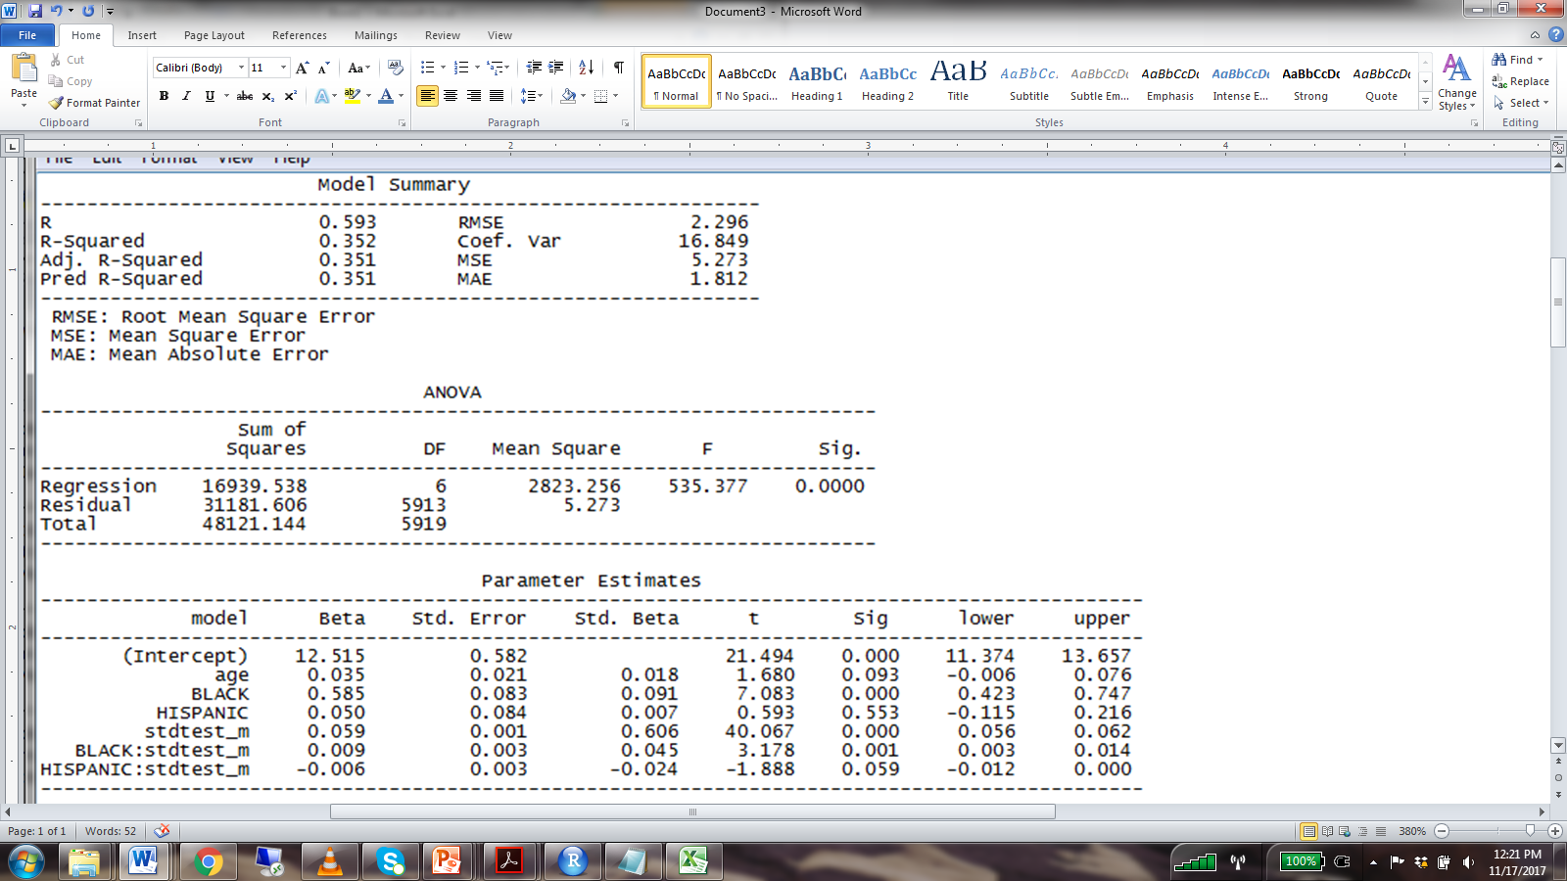

1. Interpret the beta for stdtest_m.
2. Interpret the beta for BLACK:stdtest_m.
3. Write the reduced form of the equation that relates stdtest_m to yrseduc for Black individuals.
4. Write the reduced form of the equation that relates stdtest_m to yrseduc for Hispanic individuals.
5. Write the reduced form of the equation that relates stdtest_m to yrseduc for White individuals.
6. Write the reduced form of the equation that relates BLACK to yrseduc for individuals with stdtest_m scores one standard deviation above the mean.
7. What is the predicted yrseduc score for a 20 y/o WHITE individual with a stdtest_m score 1.5 standard deviations below the mean?